Deploying application for generating random numbers using fargate service.

Image pushed to ECR –

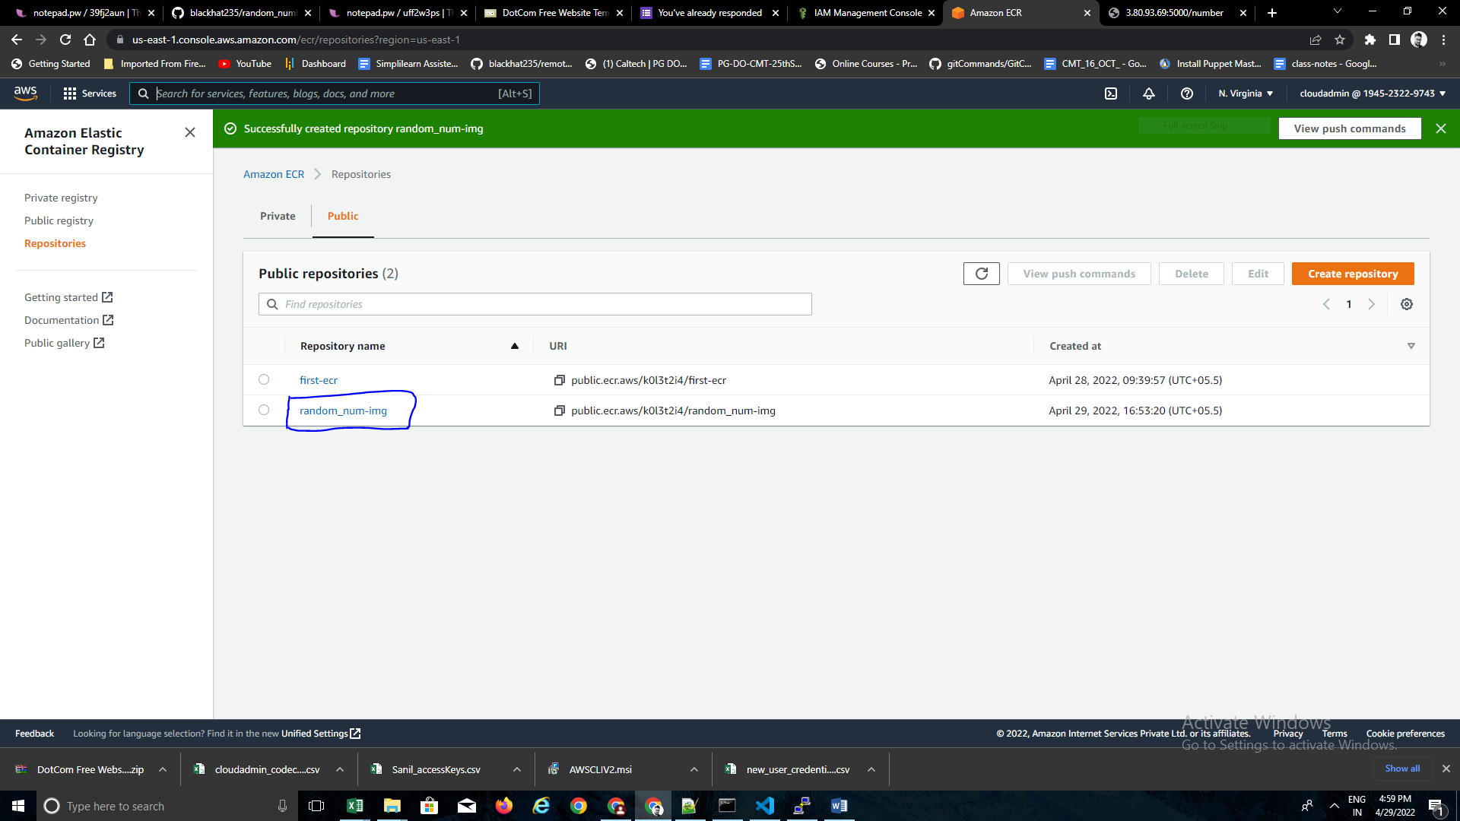

Service created within cluster :

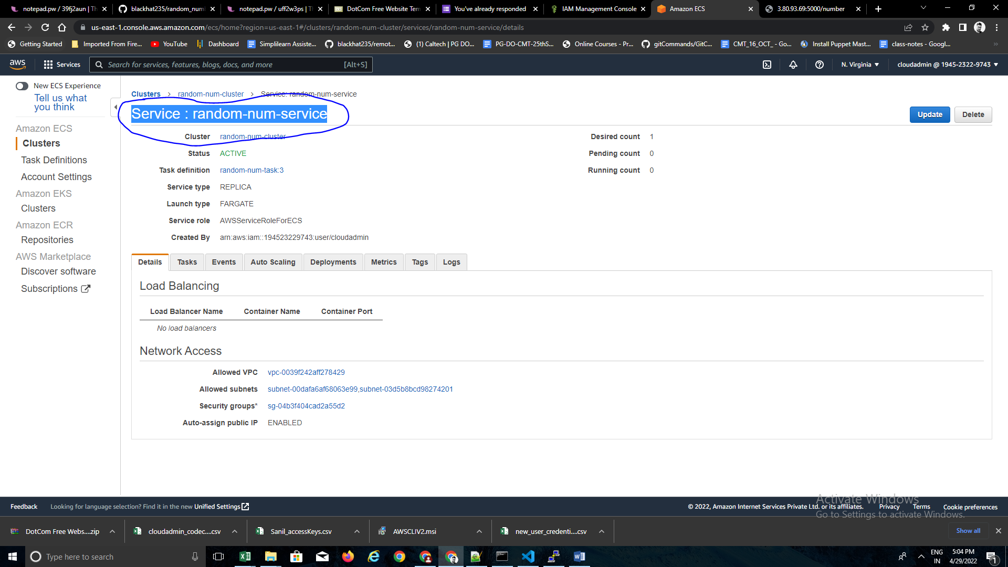

Task definition created :

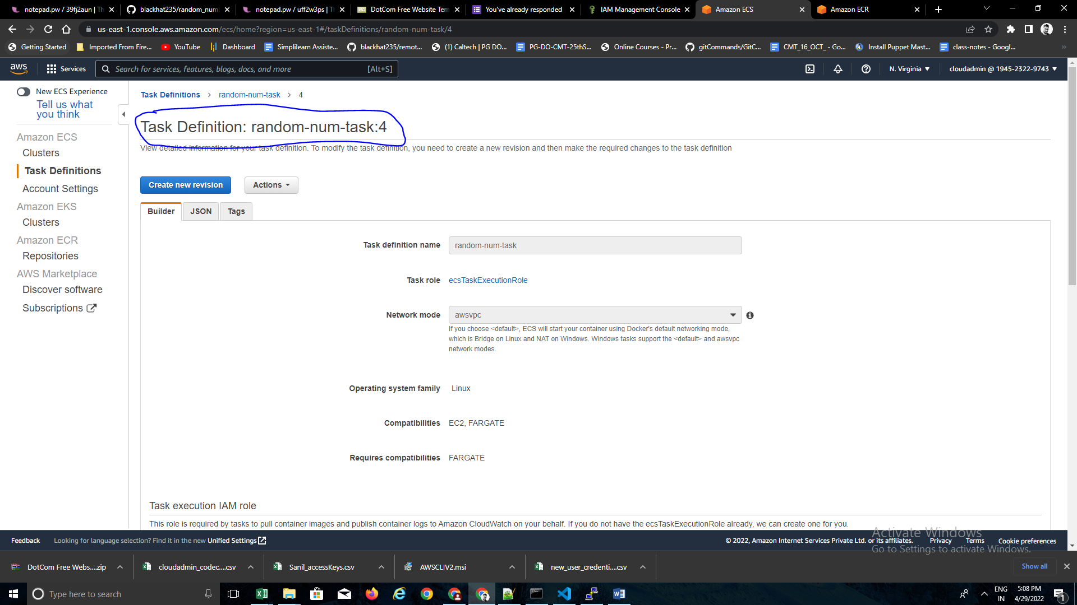

One more rule added while creating service:

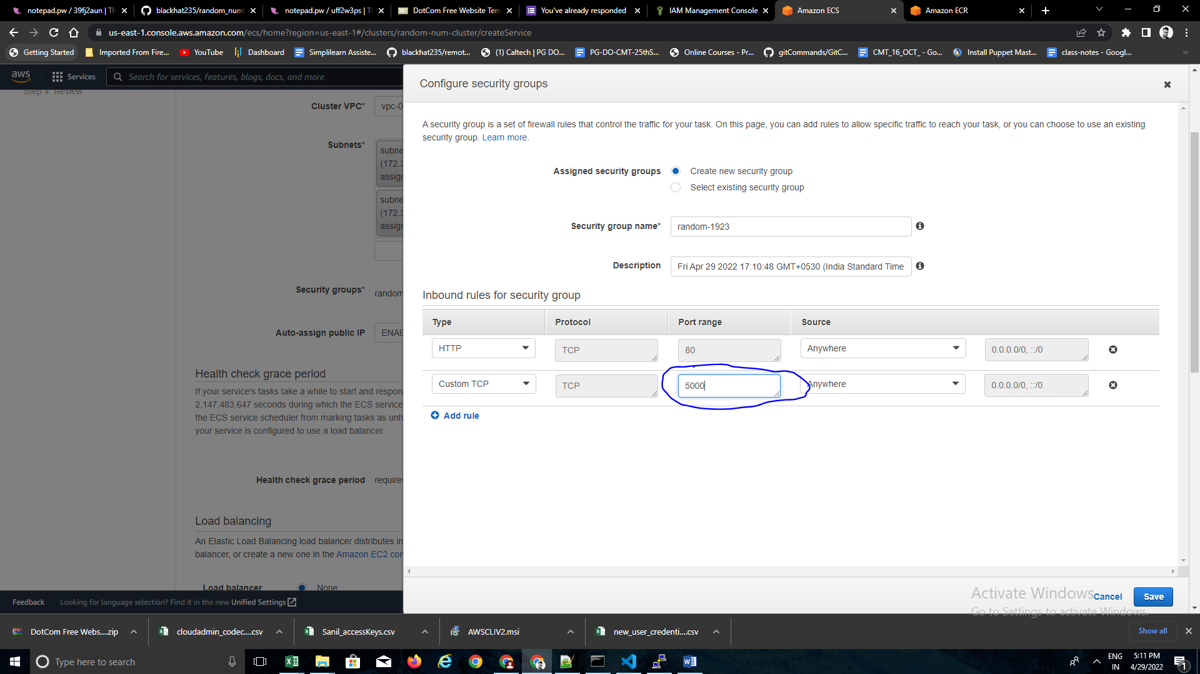

Service created and task is in running status:

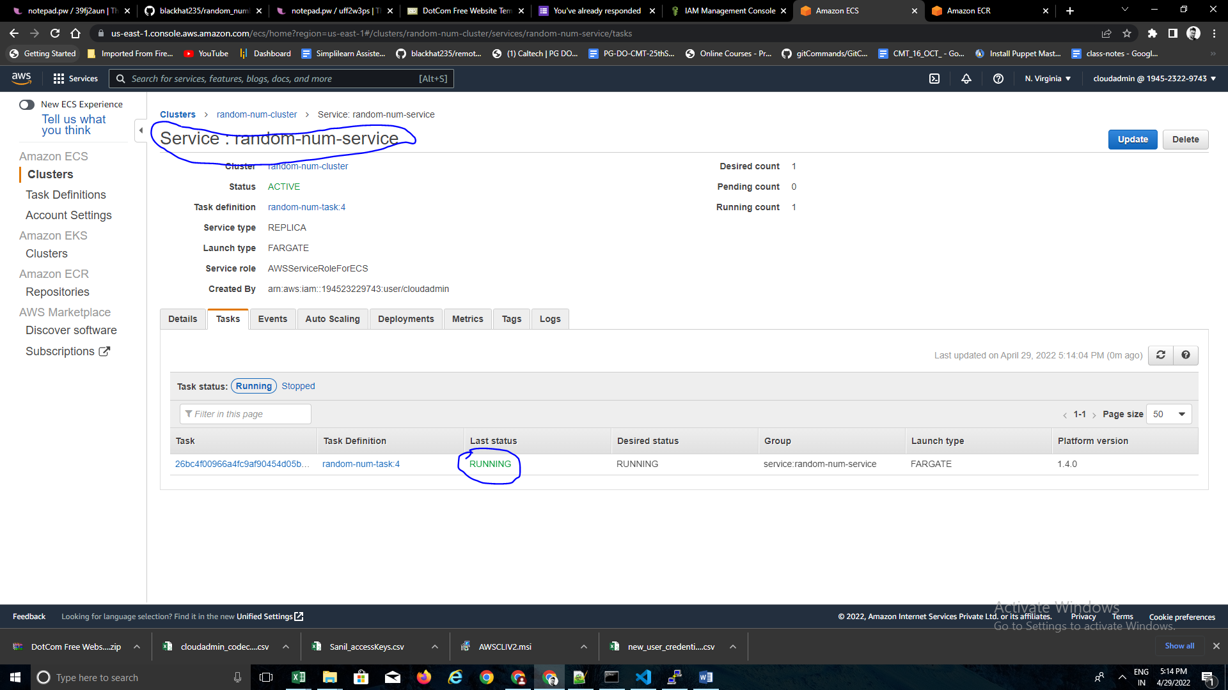

Application running successfully on ‘/’ using fargate service:



Application running successfully on ‘/number’ using fargate service:

Generating random number as required.

